**TRIBHUVAN UNIVERSITY**

**FACULTY OF HUMANITIES AND SOCIAL SCIENCE**

**Project Proposal**

**on**

**“KharchaTrack : Smart Expenses Tracker with Insights”**

**Submitted to**

**Department of Computer Application**

**National College of Computer Studies**

In partial fulfilment of the requirements

of

Bachelor’s Degree in Computer Application

**Submitted By:**

**Reman Buddhacharya**

**(6-2-551-36-2021)**

**Under Supervision of**

**Mr. Yuba Raj Devkota**



**Tribhuvan University**

**Faculty of Humanities and Social Sciences**

**National College of Computer Studies**

# Supervisor’s Recommendations

I hereby recommend that this project prepared under my supervision by **Reman Buddhacharya** entitled “**KharchaTrack : Smart Expenses Tracker with Insights**” in partial fulfillment of the requirements for a degree of Bachelors in Computer Application is recommended for the final evaluation.

______________

**SIGNATURE**

**Mr. Yuba Raj Devkota**

**SUPERVISOR**

**Faculty Member**

**Department of Computer Application**

**National College of Computer**



**Tribhuvan University**

**Faculty of Humanities and Social Sciences**

**National College of Computer Studies**

# Letter of Approval

This is to certify that this project prepared by **Reman Buddhacharya** entitled “**KharchaTrack : Smart Expenses Tracker with Insights**” in partial fulfillment of the requirements for the degree of Bachelors in Computer Application has been evaluated. In our opinion, it is satisfactory in scope and quality as a project for the required degree.

|  |  |
| --- | --- |
| **Signature of Supervisor**  Mr. Yuba Raj Devkota  Faculty Member  Department of Computer Application  National College of Computer Studies  Paknajol, Kathmandu | **Signature of HOD / Coordinator**  Mr. Rajan Poudel  Faculty Member  Department of Computer Application  National College of Computer Studies  Paknajol, Kathmandu |
| **Signature of Internal Examiner** | **Signature of External Examiner** |

# Abstract

KharchaTrack is a smart expense tracking web application designed to revolutionize personal financial management. Unlike traditional expense trackers, it leverages algorithms such as Moving Average for forecasting and Isolation Forest for anomaly detection to offer meaningful insights into users' financial habits. Built using Laravel, and Livewire, KharchaTrack enables real-time monitoring, predictive analytics, and anomaly alerts, all through a user-friendly interface. This system aims to enhance user experience in expense planning, fraud detection, and overall budget management.

**Keywords:** *KharchaTrack, expense tracking, Laravel, Moving Average, Isolation Forest, financial forecasting, anomaly detection*.

# Acknowledgement

Completing this study in its present form has been an enriching and rewarding experience. I would like to express my sincere gratitude to all the people who have supported me throughout this project.

First and foremost, I extend my heartfelt thanks to the BCA department for their guidance, supervision, and invaluable support in completing this project. Their assistance and advice have been instrumental in shaping this project.

I would also like to thank all the individuals who contributed directly or indirectly to the success of this project. Their insights, feedback, and encouragement were invaluable.

Finally, I would like to express my gratitude to the readers of this report, who will hopefully benefit from this work. I hope that this report will provide useful insights and inspire further research in this field.

# Table of Content

Supervisor’s Recommendations i

Letter of Approval ii

Abstract iii

Acknowledgement iv

Table of Content v

List of Abbreviation vii

List of Figures viii

Chapter 1: Introduction 1

1.1. Introduction 1

1.2. Problem Statement 2

1.3. Objective 2

1.4. Scope and Limitation 3

1.5. Development Methodology 3

1.6. Report Organization 5

1.6.1. Introduction 5

1.6.2. Background Study and Literature Review 5

1.6.3. System Analysis and Design 5

1.6.4. Implementation and Testing 5

1.6.5. Conclusion and Future Recommendations 5

Chapter 2: Background Study and Literature Review 6

2.1. Background Study 6

2.2. Study of Existing Systems 6

2.3. Literature Review 7

Chapter 3: System Analysis and Design 9

3.1. System Analysis 9

3.1.1. Requirement Analysis 9

3.1.2. Feasibility Analysis 10

3.1.2.1. Technical Feasibility 10

3.1.2.2. Operational Feasibility 11

3.1.2.3. Economic Feasibility 11

3.1.3. Object Modelling: Object and Class Diagram 12

3.1.4. Dynamic Modelling : State and Sequence Diagram 16

3.1.5 Process Modelling: Activity Diagram 19

3.2. System Design 21

3.2.1. Refinement of Classes and Objects 21

3.2.2. Component Diagram 25

3.2.3. Deployment diagram 26

3.3. Algorithm Details 27

Chapter 4: Implementation and Testing 29

4.1. Implementation 29

4.1.1. Tools used 29

4.1.2. Implementation details of modules 30

4.2. Testing 34

Chapter 5: Conclusion and Future Recommendations 41

5.1. Lesson Learnt / Outcome 41

5.2. Conclusion 41

5.3. Future Recommendations 41

References 43

Appendix i

# List of Abbreviation

APIs Application Programming Interface

CSS Cascading Style Sheets

CSV Comma-separated values

HTML HyperText Markup Language

MA Moving Average

PDF Portable Document Format

PHP Personal Home Page

PWA Progressive Web App

SMS Short Message Service

UI User Interface

YNAB You Need a Budget

# List of Figures

Figure 1.1: Waterfall Model 3

Figure 3.1: Use Case Diagram with Online User 9

Figure 3.2: Object Diagram 12

Figure 3.3: Class Diagram 14

Figure 3.4: State Diagram 16

Figure 3.5: Sequence Diagram 17

Figure 3.6: Activity Diagram 19

Figure 3.7: Refinement of Classes 21

Figure 3.8: Refinement of Object 23

Figure 3.9: Component Diagram 25

Figure 3.10: Deployment Diagram 26

# Chapter 1: Introduction

## Introduction

Effective financial management is essential for both individuals and businesses. However, tracking expenses manually or using basic expense trackers often lacks deeper insights, making it difficult to forecast future spending or detect fraudulent transactions. This highlights the need for a smarter, data-driven solution.

KharchaTrack is a smart expense tracker designed to address these challenges. It will provide automated expense tracking, forecasting, and fraud detection. Unlike conventional expense trackers, KharchaTrack will analyze spending patterns to predict future expenses and identify unusual transactions that may indicate fraud.

This project will be developed using Laravel, and Livewire , ensuring a scalable, interactive, and efficient financial management system. The combination of these technologies will allow for real-time data processing, intuitive user interactions, and advanced predictive analytics.

This proposal outlines the development of KharchaTrack, including its objectives, methodology, expected outcomes, and implementation plan. The project aims to create a comprehensive expense management tool that not only records transactions but also helps users make informed financial decisions with algorithm powered insights.

## Problem Statement

In today's fast-paced world, managing personal finances has become increasingly challenging. Many individuals struggle with tracking their expenses, identifying spending patterns, and avoiding unnecessary financial strain. Traditional methods, such as manual logs or basic spreadsheets, lack real-time insights and predictive capabilities.

Moreover, fraudulent transactions and unusual spending behaviors often go unnoticed, leading to financial losses. Existing expense trackers mostly focus on recording transactions without providing intelligent forecasting or anomaly detection to help users make better financial decisions.

This project aims to develop a Smart Expense Tracker using Laravel, and Livewire that integrates Moving Average for expense forecasting and Isolation Forest for anomaly detection. This system will not only allow users to log and categorize expenses but also provide future expense predictions and alert users to potentially suspicious transactions.

By leveraging algorithms as Moving Average and Isolation forest, this solution will empower users with data-driven financial insights, helping them make informed decisions, detect anomalies, and improve their spending habits.

## Objective

The main objective of KharchaTrack is:

* To help users manage expenses efficiently through data-driven insights, expense prediction, and anomaly detection.

## Scope and Limitation

The primary scope of KharchaTrack is to develop a web application that predicts users’ future expenses and flags unusual or potentially fraudulent transactions. The system supports user account management, automatic and manual categorization of expenses, export of data, and real-time dashboard insights. It is designed for general users looking to manage personal finances more efficiently.

Limitations include the need for an internet connection for real-time functionality, reliance on historical data for accurate forecasting, and limited support for multi-user organization-level deployment. Additionally, while the application offers self-hosting capability, it assumes users have the technical expertise to deploy it manually if desired.

## Development Methodology

This project is on a small scale and has well-defined requirements and a linear approach. Under such development circumstances, the simplest development model, the waterfall model, is applicable. The waterfall model produces a set of documents after each stage, as well as a time frame that is enough to implement the project under the methodology.

[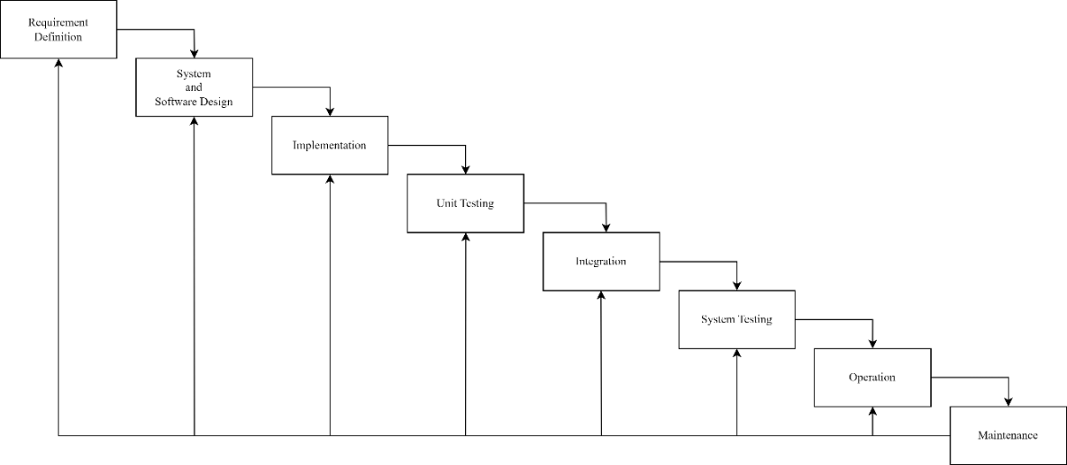](https://viewer.diagrams.net/?tags=%7B%7D&highlight=0000ff&edit=_blank&layers=1&nav=1&title=GitPass.drawio#Uhttps%3A%2F%2Fdrive.google.com%2Fuc%3Fid%3D1E7y98-vr-dIPOv_xKlNOeTsmVWm3caGa%26export%3Ddownload)

Figure .1: Waterfall Model

1. **Requirement Definition**: The requirements for KharchaTrack were defined in this stage, including the features and functionality that the application should have. This stage involved researching, analyzing, and identifying the key requirements for the application.
2. **System and Software Design**: Based on the requirements defined in the previous stage, a detailed plan for the application was created in the system and software design stage. This included defining the application architecture, data structures, and user interface design.
3. **Implementation**: The implementation stage was carried out, where the application was coded based on the system and software design created in the previous stage. This stage involved writing the code and testing the application as it was developed.
4. **Unit Testing**: Individual components of the application were tested in this stage to ensure that they worked as expected. This stage involved creating test cases and running tests to verify the functionality of the code.
5. **Integration**: The integration stage involved combining the individual components of the application into a single working application. This stage also included testing the integrated application to ensure that all components worked together seamlessly.
6. **System Testing**: The entire application was tested in the system testing stage to ensure that it met the requirements defined in the first stage. This stage involved testing the application in a real-world environment and identifying any issues that may have arisen.
7. **Operation**: The operation stage involved deploying the application to a live environment and making it available to users. This stage included monitoring the application to ensure that it functioned properly and addressing any issues that arose.
8. **Maintenance**: The maintenance stage will involve making updates and improvements to the application over time. This stage will include fixing bugs, adding new features, and ensuring that the application remains up to date with the latest technologies and standards.

## Report Organization

### Introduction

This chapter provides an overview of the project, including the problem it aims to solve, the project objectives, scope and limitations, and development methodology of the project.

### Background Study and Literature Review

This chapter focuses on study of existing systems and review of different articles studied.

It also explores the underlying concepts and principles that informed the development of the system.

### System Analysis and Design

This chapter covers the project's requirements analysis, feasibility assessment, and design. System Models as Object & Class Diagram, State & Sequence Diagram, and Activity Diagram and System Designs as Refinement of Class and Object, Component Diagram and Deployment Diagram are all included.

### Implementation and Testing

This chapter provides details on the project's implementation, the software and tools used, and the types of testing conducted.

### Conclusion and Future Recommendations

This chapter discusses the project's potential outcomes and summarizes the main findings. It also provides recommendations for future work.

# Chapter 2: Background Study and Literature Review

## 2.1. Background Study

With the rise in digital transactions and the complexity of financial management, individuals face challenges in tracking and understanding their expenses. Existing solutions like Mint, YNAB, and Expensify primarily offer basic expense tracking, budgeting, and visualization features. However, they fall short in offering predictive insights or fraud detection.

KharchaTrack was conceived as an answer to these limitations by integrating two major algorithms into expense management. It builds on established techniques such as Moving Average for financial forecasting and Isolation Forest for anomaly detection. These methods have proven effective in various domains for predictive modeling and outlier detection, and their application in this context offers a significant enhancement over conventional trackers.

## 2.2. Study of Existing Systems

Several existing expense tracking applications dominate the market, offering a variety of budgeting and reporting tools. However, they each have their limitations:

* **Mint**: Mint is a widely used financial planning tool that provides budgeting, bill tracking, and account aggregation. While it offers auto-categorization of expenses and basic insights, it lacks intelligent forecasting and anomaly detection features essential for modern financial analysis [1].
* **YNAB (You Need A Budget)**: This application promotes a strict budgeting methodology and helps users plan every dollar they earn. Although effective for discipline-driven budgeting, YNAB requires manual inputs and does not utilize predictive analytics or anomaly detection [2].
* **Expensify**: Geared primarily toward business expense reporting, Expensify includes receipt scanning and reimbursement management. However, it lacks personal budgeting features and fails to provide predictive insights based on historical patterns [3].

These tools provide helpful functionality, but their scope is limited to static data representation and manual financial tracking. KharchaTrack introduces intelligent features by integrating algorithms such as Moving Average for expense forecasting and Isolation Forest for identifying abnormal expenses. This algorithm based approach enables users to gain real-time insights, recognize spending trends, and proactively respond to financial anomalies.

## 2.3. Literature Review

Expense tracking systems have significantly evolved over the past decades, transitioning from manual record-keeping to intelligent, automated platforms. Traditional methods like pen-and-paper logs and spreadsheets were often prone to human error and lacked analytical capabilities [4]. The rise of early digital solutions such as Quicken enabled users to categorize expenses and visualize budgets but still required manual effort [5].

Modern expense tracking applications like Mint, YNAB, and Expensify have integrated automation and cloud synchronization to streamline financial management. Mint automatically links bank accounts, categorizes transactions, and provides budget alerts [1]. YNAB (You Need a Budget) emphasizes proactive, rule-based budgeting where users assign every dollar a “job” before spending, encouraging disciplined financial habits [2]. Expensify, targeted more toward business users, offers smart receipt scanning using OCR and real-time anomaly detection for policy compliance [3].

While these tools have improved convenience, they are largely reactive. Recent academic and industry research has explored the integration of algorithms to make expense tracking predictive and insightful. Moving Average (MA) algorithms are widely used in financial applications to forecast future spending trends by smoothing out short-term fluctuations [6]. In the context of personal finance, this technique can help users plan budgets based on past behavior.

For anomaly detection, Isolation Forest has gained attention for its effectiveness in identifying unusual expense patterns. This unsupervised learning algorithm isolates data points by randomly selecting features and splitting values, making outliers easier to detect as they require fewer partitions [7]. The algorithm has been used in both academic projects and commercial systems for fraud detection and behavioral analysis.

Recent studies support the effectiveness of integrating algorithms into personal finance applications. Wibowo et al. [8] conducted a comprehensive performance analysis of conventional moving average methods including Simple Moving Average (SMA), Weighted Moving Average (WMA), and Exponential Moving Average (EMA) in financial forecasting, demonstrating their effectiveness in identifying trends and patterns in transaction data. Their findings showed that moving average techniques provide reliable baseline forecasting capabilities for expense prediction systems. Similarly, Liu et al. [9] introduced the foundational Isolation Forest algorithm specifically for anomaly detection, proposing a novel model-based method that explicitly isolates anomalies instead of profiling normal data points. Their research established that isolation-based approaches achieve linear time complexity and superior performance in detecting outliers, making them highly suitable for identifying unusual spending patterns and potential fraudulent transactions in financial applications.

In summary, existing systems provide helpful tools for budget management, but their predictive and anomaly detection capabilities are limited. The integration of algorithms like Moving Average and Isolation Forest into applications such as KharchaTrack presents a valuable innovation. These algorithm-powered features can enable users not only to track and categorize their expenses but also to receive forward-looking insights and alerts on unusual activity, thereby making personal finance management more intelligent and secure.

# Chapter 3: System Analysis and Design

## 3.1. System Analysis

### 3.1.1. Requirement Analysis

Requirements were collected through personal evaluation of different existing systems, along with suggestions from mentors, classmates, and supervisors.

1. Functional Requirements

[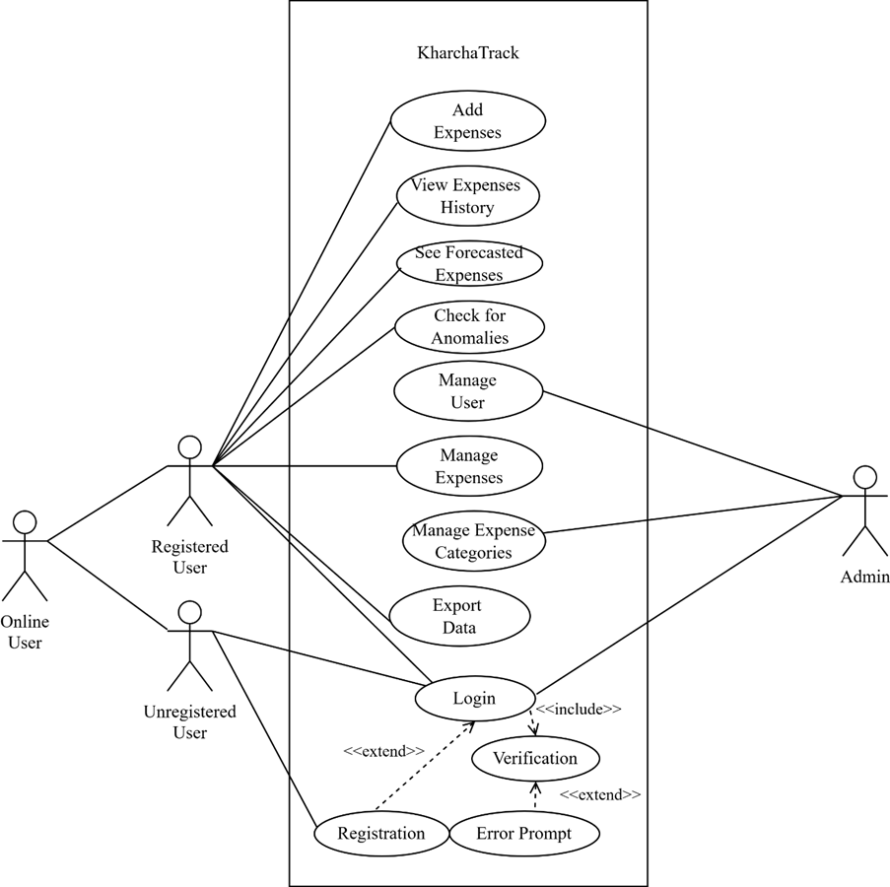](https://viewer.diagrams.net/?tags=%7B%7D&highlight=0000ff&edit=_blank&layers=1&nav=1&title=GitPass.drawio#Uhttps%3A%2F%2Fdrive.google.com%2Fuc%3Fid%3D1E7y98-vr-dIPOv_xKlNOeTsmVWm3caGa%26export%3Ddownload)

Figure 3.1: Use Case Diagram with Online User

The use case diagram in previous page specifies the basic operations a user can perform in the proposed system.

* Users can create an account and log in with unique credentials.
* Password recovery is available if users forget their credentials.
* Users can add, view, update, and delete expense entries, with timestamps for each transaction.
* Expenses can be categorized automatically or manually.
* The system predicts future expenses using the Moving Average algorithm.
* Isolation Forest detects and flags unusual or potentially fraudulent transactions.
* Users can view and revert to previous versions of their expense entries.
* A personalized dashboard displays expense summaries, forecasts, and anomalies.
* Users are notified about forecasted expenses and flagged transactions.
* Users can export expense data to CSV or PDF formats.
* The system is compatible with modern web browsers.

1. Non-Functional Requirements

* The application should provide real-time updates for expense tracking and forecasting with minimal latency.
* The system should be able to handle a growing number of users and increasing expense data without performance issues.
* The platform should have an intuitive and user-friendly interface to make navigation and expense management easy.
* The dashboard should display clear insights and be simple to use.
* The system should be available 24/7 with minimal downtime for maintenance or updates.
* Regular backups of user data should be taken to ensure data integrity.
* The system should be compatible with all modern web browsers (e.g., Chrome, Firefox, Edge).
* It should be responsive and function well on both desktop and mobile devices.
* The application should have clean, modular code that is easy to update and maintain over time.

### 3.1.2. Feasibility Analysis

The system is evaluated for future development with a set of constraints. The feasibility study is done regarding the available technologies, time constraints, area of application, cost of deployment and upkeep, and future possibilities of the project.

#### 3.1.2.1. Technical Feasibility

KharchaTrack will be developed using stable, open-source technologies. The frontend will use HTML, CSS, and JavaScript, with Livewire for real-time updates. The backend will be powered by Laravel, ensuring a secure and efficient architecture. PostgreSQL will store user data securely. PHP classes will handle algorithms like Moving Average and Isolation Forest for forecasting and anomaly detection. The system will be web-based and compatible with modern browsers and mobile devices, ensuring accessibility from anywhere. Development will be done using free software like Visual Studio Code and GitHub.

#### 3.1.2.2. Operational Feasibility

The user interface of KharchaTrack will be designed to be intuitive and user-friendly, ensuring ease of use for individuals of all technical backgrounds. Similar to existing expense tracking applications, the interface will feature simple navigation and interactive elements for a smooth user experience. The platform will be responsive, ensuring compatibility across various devices, including desktops, tablets, and mobile phones. By following basic design principles, the application will be easy to understand, enabling users to quickly adopt and effectively manage their expenses.

#### 3.1.2.3. Economic Feasibility

Most of the software used for developing this project will be open source and free. Along with it, suitable cloud hosting will be used as 000webhostapp or infinityfree. All of the technology used will be free of cost for developing this project.

## 

### A screenshot of a computer3.1.3. Object Modelling: Object and Class Diagram

Figure .2: Object Diagram

The object diagram provides a concrete example of how actual data instances relate to each other in the system:

* It shows a user named "Remon Buddhacharya" with sample data including two categories ("Food" and "Transportation") and two expenses ("Lunch" for RS500 and "Bus fare" for RS100).
* The ExpenseHistory object shows a previous state of the "Lunch" expense when it cost RS450, demonstrating how expense modifications are tracked.
* Sample Forecast and Anomaly objects are shown, with the Anomaly flagging the "Lunch" expense for an "Unusual amount" with a confidence score of 0.85.

This diagram helps visualize how real data flows through the application, making the relationships more concrete and understandable.

Figure 3.3: Class Diagram

This diagram defines the model and data structure of your expense tracking system.

**Component Interactions**:

* **User-Expense Relationship**: One user can have many expenses (1 to *), establishing ownership of financial data.
* **User-Category Relationship**: One user (admin) can create many categories (1 to *), allowing personalized expense organization.
* **Category-Expense Relationship**: One category can contain many expenses (1 to *), enabling classification of spending.
* **Expense-ExpenseHistory Relationship**: One expense tracks many history records (1 to *), implementing an audit trail feature.
* **Expense-Anomaly Relationship**: Expenses can be flagged by the anomaly detection system (1 to *), marking unusual spending patterns.

This diagram forms the foundation of the data model, showing how entities relate to each other and defining the core business objects. The diamond notation (--o) indicates composition relationships, where parent entities "own" child entities.

### 3.1.4. Dynamic Modelling : State and Sequence Diagram

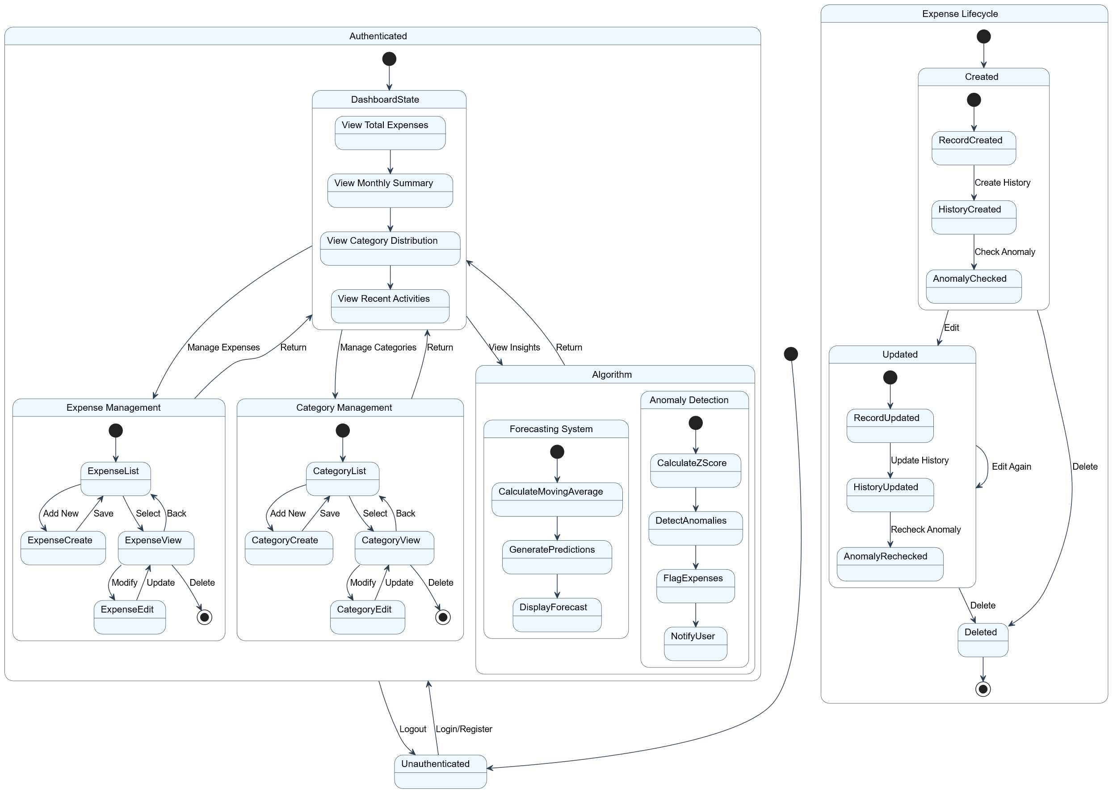

Figure 3.4: State Diagram

The state diagram depicts both user authentication states and expense lifecycle states:

* **Authenticated User States**: Within the Authenticated composite state, it shows navigation between Dashboard, ExpenseManagement, CategoryManagement, and other features.
* **Expense Lifecycle States**: The Expense state machine shows how an expense transitions from Created → Updated → Deleted, with History records created for each state change.

This diagram helps understand both how users navigate through the system and how data entities change throughout their lifecycle.

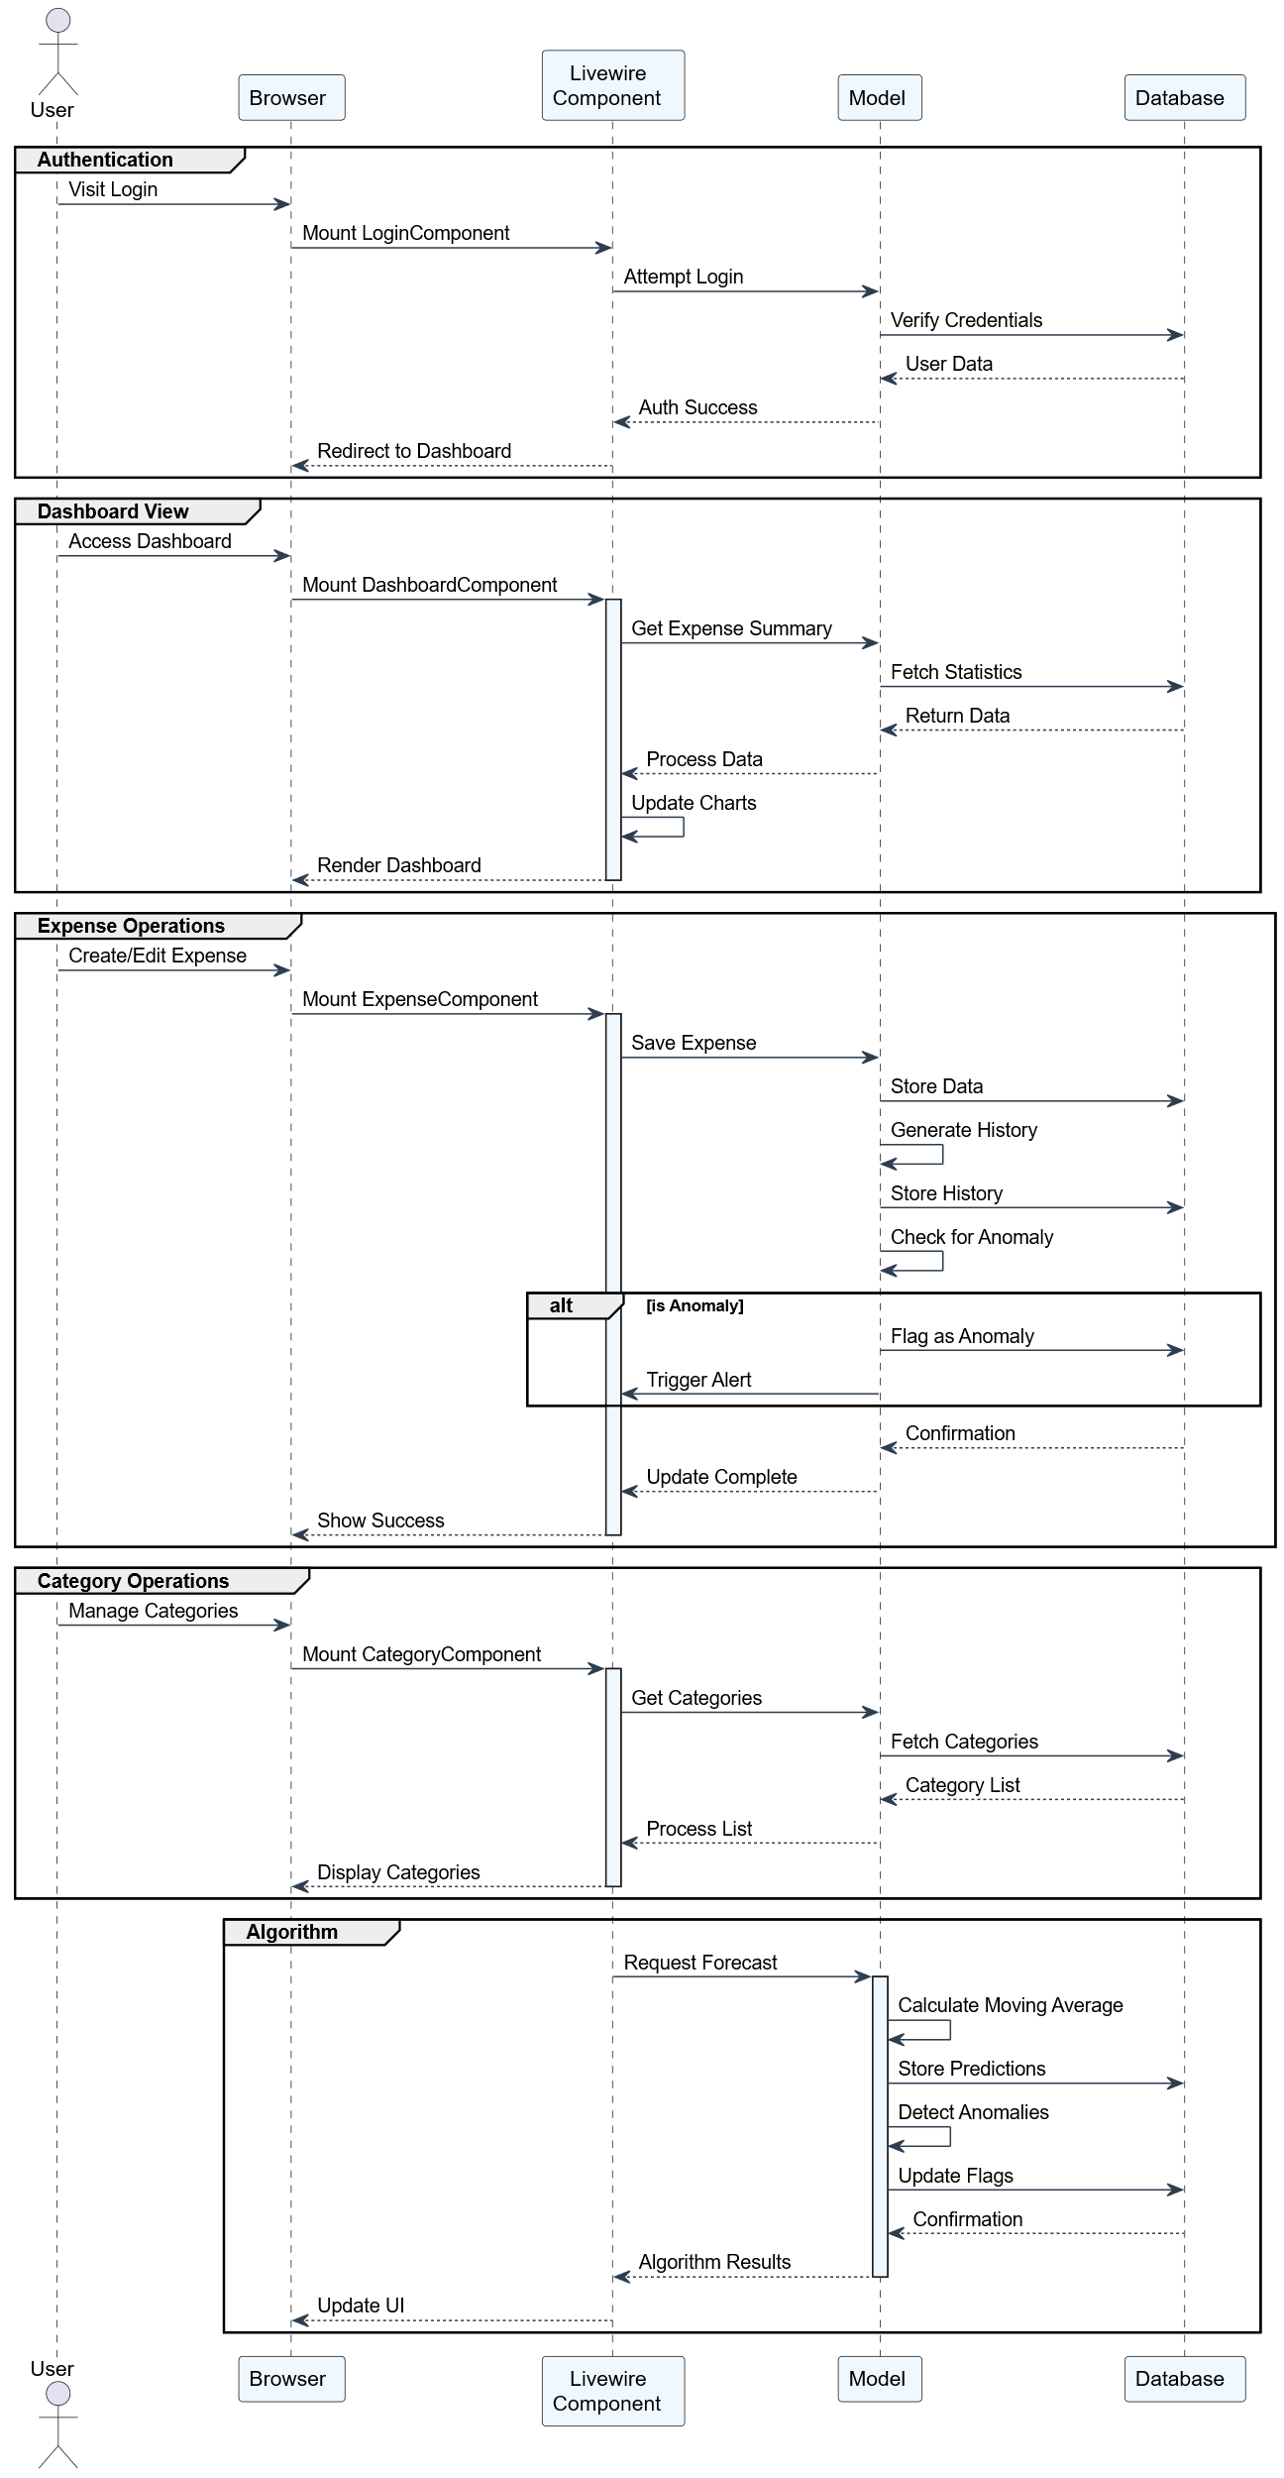

Figure 3.5: Sequence Diagram

The sequence diagram for KharchaTrack illustrates the temporal interactions and message flow across five key modules:

1. **Authentication**: Shows the interaction from the user's login request to credential verification by the model and database. Upon successful authentication, the user is redirected to the dashboard.
2. **Dashboard View**: Displays how the dashboard component retrieves and processes expense summary data by interacting with backend models and the database to render analytical charts.
3. **Expense Operations**: Details the process for creating or editing an expense. It includes saving data, generating and storing history, checking for anomalies, and, if detected, flagging them and triggering an alert.
4. **Category Operations**: Explains how category data is fetched and processed for display. The system retrieves a list of categories from the database and updates the user interface accordingly.
5. **Algorithm**: Demonstrates how the application handles forecasting and anomaly detection. It shows the sequence of calculating moving averages, storing predictions, detecting anomalies, updating anomaly flags, and displaying results back to the user interface.

This diagram provides a comprehensive overview of component-level communication and timing in the KharchaTrack system, emphasizing its modular, event-driven architecture and intelligent financial processing.

### 3.1.5 Process Modelling: Activity Diagram

Figure 3.6: Activity Diagram

The activity diagram displays the system flow of the project, organized into color-coded vertical swim lanes:

* **Auth (White)**: Begins with authentication flow including "Authenticated?" decision point, Login action, and "Valid?" verification before granting system access.
* **Dashboard (Light Beige)**: After authentication, users can "View Stats" and navigate to three parallel options: Expenses, Categories, or Anomalies.
* **Expenses (Light Cyan)**: Shows flow for expense management with "List View" followed by three options (Create, Edit, Delete), all concluding with "Log History."
* **Categories (Light Green)**: Similar to expenses section with "List View" but includes a decision point "Has Expenses?" that determines whether categories can be deleted. If yes, there's a "Block Delete" action; if no, normal "Delete" is permitted. "Create" and "Edit" actions are also available.
* **Algorithm (Pink)**: Shows algorithm functionality including "Detect Anomalies," "Forecast," a decision point "Found?" with "Show Predictions" and "Alert User" actions.
* **System (White)**: Contains system functions like "Update UI" and "Save State."
* **User (White)**: Shows a "View/Logout" option concluding the flow.

The diagram uses consistent visual symbols with rounded rectangles for actions, diamond shapes for decision points, and arrows showing flow direction. A legend at the bottom maps each colored area to its function.

## 3.2. System Design

### 3.2.1. Refinement of Classes and Objects

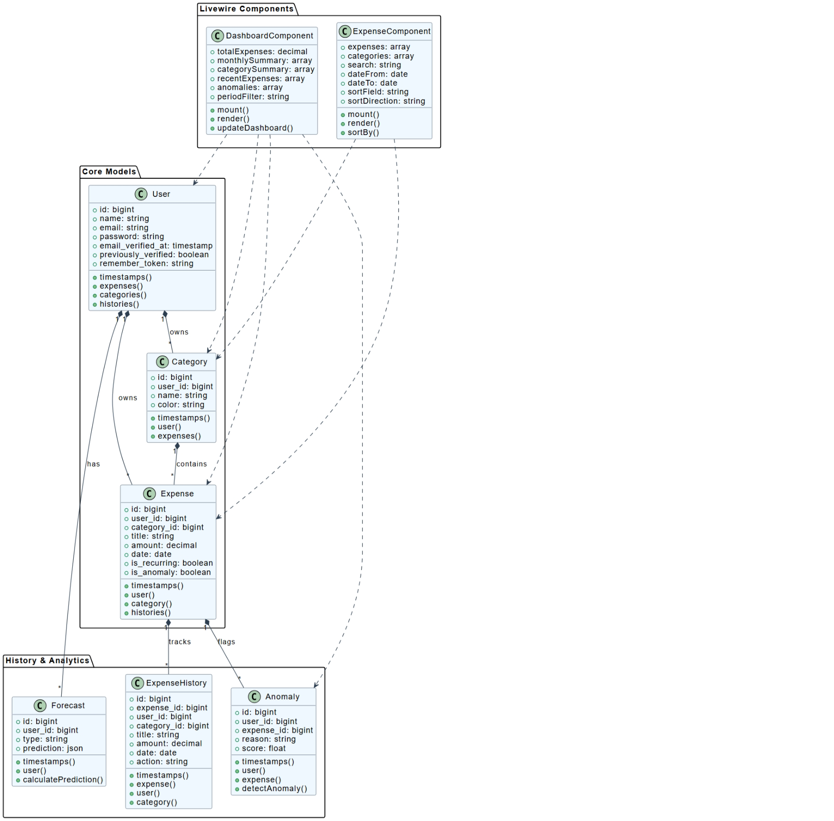

Figure 3.7: Refinement of Classes

The diagram shows a class diagram for a financial tracking application with the following structure:

* **Livewire Components**: Located at the top, showing UI components:
  + **DashboardComponent**: Contains properties for financial data display (totalExpenses, monthlySummary, categorySummary, recentExpenses, anomalies, periodFilter) and methods (mount(), render(), updateDashboard()).
  + **ExpenseComponent**: Includes properties for handling expense data (expenses, categories, search, dateFrom, dateTo, sortField, sortDirection) and methods (mount(), render(), sortBy()).
* **Core Models**: Central section containing foundational data structures:
  + **User**: Stores user information (id, name, email, password, email_verified_at, previously_verified, remember_token) with methods (timestamps(), expenses(), categories(), histories()).
  + **Category**: Manages expense categories (id, user_id, name, color) with methods (timestamps(), user(), expenses()).
  + **Expense**: Records financial transactions (id, user_id, category_id, title, amount, date, is_recurring, is_anomaly) with methods (timestamps(), user(), category(), histories()).
* **History & Analytics**: Bottom section for tracking changes and predictions:
  + **ExpenseHistory**: Logs expense modifications (id, expense_id, user_id, category_id, title, amount, date, action) with methods (timestamps(), expense(), user(), category()).
  + **Forecast**: Generates financial predictions (id, user_id, type, prediction) with methods (timestamps(), user(), calculatePrediction()).
  + **Anomaly**: Flags unusual transactions (id, user_id, expense_id, reason, score) with methods (timestamps(), user(), expense(), detectAnomaly()).

The diagram shows relationships between classes with solid and dashed lines indicating ownership, composition, and dependencies.

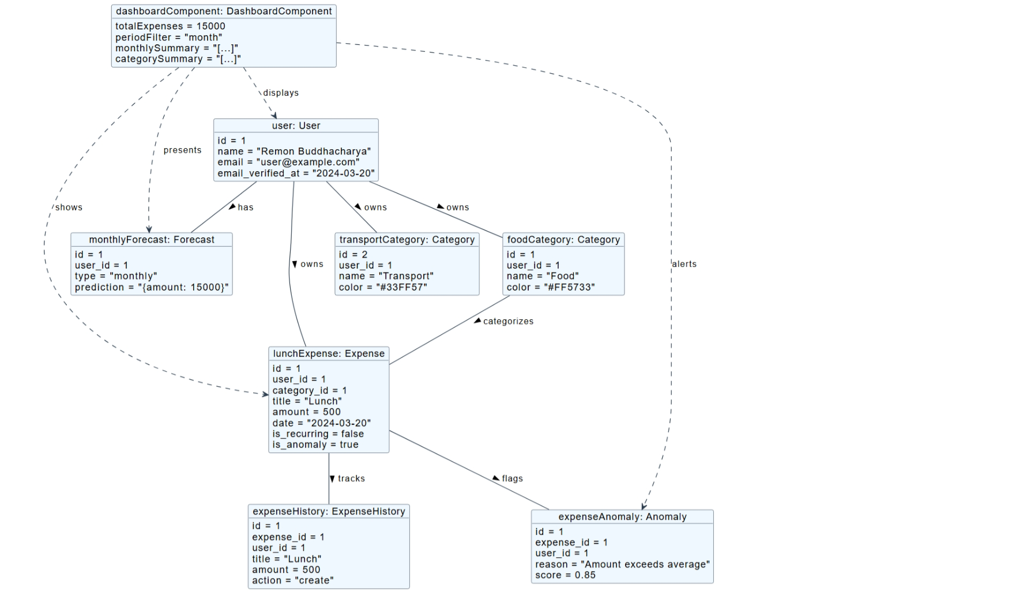

Figure 3.8: Refinement of Object

The diagram shows an object diagram for a financial tracking application that illustrates specific instances and their relationships:

* **DashboardComponent**: Contains actual data values (totalExpenses = 15000, periodFilter = "month") that displays financial information.
* **User**: Shows a specific user instance (id = 1, name = "Remon Buddhacharya", email = "[user@example.com](mailto:user@example.com)") who owns categories and has forecast data.
* **Category**: Two specific categories are shown:
  + **transportCategory**: A transport expense category (id = 2, name = "Transport", color = "#33FF57")
  + **foodCategory**: A food expense category (id = 1, name = "Food", color = "#FF5733")
* **Expense**: Contains a specific expense instance (lunchExpense) with concrete values (id = 1, title = "Lunch", amount = 500, date = "2024-03-20", is_recurring = false, is_anomaly = true).
* **ExpenseHistory**: Tracks a specific history record (id = 1) for the lunch expense with action = "create".
* **Anomaly**: Shows an anomaly instance (expenseAnomaly) flagging the lunch expense with reason = "Amount exceeds average" and score = 0.85.

The diagram uses solid and dashed lines with directional labels ("owns", "categorizes", "tracks", "flags", etc.) to show how these specific objects relate to each other during runtime.

### A screenshot of a computer3.2.2. Component Diagram

Figure 3.9: Component Diagram

The component diagram describes the system architecture across four layers:

* **Presentation Layer**: Shows how Blade Templates, Layouts, Livewire/Volt Components (Dashboard, Expenses, Categories), Mary UI, and Frontend Assets interact to create the user interface. Dependencies show that Livewire renders through Blade, which uses MaryUI for styling.
* **Application Layer**: Illustrates how Routes direct requests to Controllers or mount Livewire components, with Middleware filtering requests and Service Providers bootstrapping components.
* **Domain Layer**: Shows the core data models (User, Expense, Category, ExpenseHistory) and their relationship with Events for tracking changes.
* **Infrastructure Layer**: Depicts the foundational services including Database (with Migrations, Seeders, Factories), Authentication (Sanctum), Authorization (Spatie Permissions), and File Storage.

The diagram shows clear separation of concerns with well-defined dependencies between components. For example, Models dispatch Events which create ExpenseHistory records, and Controllers use Models to interact with the Database.

### A screenshot of a computer3.2.3. Deployment diagram

Figure 3.10: Deployment Diagram

The deployment diagram shows the development environment setup:

* **Developer Laptop**: Contains the Laravel Application running via PHP Artisan Serve on port 8000, Frontend Build Process using Yarn Dev and Vite, PostgreSQL database on port 5432, and Cloudflared for tunneling.
* **Cloudflare**: Shows how Cloudflare Tunnel and DNS services route internet traffic securely to the local development environment.
* **Internet**: Represents end users accessing the application through their browsers.

Connection arrows show how components interact: PHP Artisan serves Blade templates and Livewire components, Models connect to PostgreSQL, Yarn Dev builds frontend assets, and Cloudflared creates a secure tunnel to expose the local development environment to the internet.

This setup enables development and testing without deploying to a production server, while still making the application accessible online through the Cloudflare tunnel.

## 3.3. Algorithm Details

The system for KharchaTrack employs two key algorithms for its functionalities: Moving Average for expense forecasting and Isolation Forest for anomaly detection.

1. **Moving Average Algorithm (for Expense Forecasting)**:

The **Moving Average** (MA) algorithm is used to predict future expenses based on past spending behavior. The MA method smooths out fluctuations in the data to provide a trend line that represents average expenditure over a set period. This helps users forecast their future expenses, enabling better budget management.

**Steps:**

* + **Data Collection**: The algorithm collects the user's expense data over a specified time period.
  + **Calculation of Average**: It calculates the average of expenses over the given period (e.g., weekly, monthly).
  + **Prediction**: The algorithm then uses the average to forecast future expenses, making the assumption that spending patterns will remain relatively consistent.

1. **Isolation Forest Algorithm (for Anomaly Detection)**:

The **Isolation Forest** algorithm is used to detect outliers or unusual expense patterns, which could indicate fraudulent activity or errors in data entry. This algorithm isolates anomalies by recursively partitioning the data into smaller subsets, ensuring that anomalies are more likely to be isolated in fewer partitions compared to normal data.

**Steps:**

* + **Data Splitting**: The algorithm divides the expense data into partitions, progressively isolating subsets of data.
  + **Scoring**: It assigns a score to each transaction based on how isolated it is from the rest of the data. Transactions that are isolated early on are flagged as anomalies.
  + **Detection**: Anomalous or unusual transactions are identified and flagged for review. These transactions might indicate unexpected spending or potential fraud.

In summary, The **Moving Average** algorithm helps forecast future expenses by calculating the average of past spending patterns, providing users with useful insights for budgeting. Meanwhile, the **Isolation Forest** algorithm detects outliers or anomalies, ensuring that any unexpected or potentially fraudulent expenses are flagged for further investigation. These algorithms work together to provide accurate forecasting and enhance the security of the expense tracking process in **KharchaTrack**.

# Chapter 4: Implementation and Testing

## 4.1. Implementation

### 4.1.1. Tools used

For the development of **KharchaTrack**, several tools and technologies were utilized to ensure a smooth development process and efficient system performance.

* **Visual Studio Code**: Used as the primary code editor for development. It provided debugging tools, terminal access, and plugin support which significantly enhanced productivity.
* **Laravel Framework**: A PHP-based web application framework used for back-end development, offering features like routing, Eloquent ORM, and Blade templating.
* **Livewire**: Integrated with Laravel to build dynamic interfaces using server-side rendering, allowing for real-time interaction without writing JavaScript.
* **PostgreSQL**: Served as the relational database management system to store and manage user and expense data securely and efficiently.
* **Git and GitHub**: Used for version control and collaborative code management. GitHub also served as a backup repository.

### 4.1.2. Implementation details of modules

**1. Core Modules**

**1.1 Authentication Module**

The system uses Laravel's built-in authentication with some customizations.

**1.2 Expense Management Module**

The core expense tracking functionality is implemented through:

// app/Models/Expense.php

class Expense extends Model {

protected $fillable = [

'user_id', 'category_id', 'title', 'amount',

'description', 'date', 'is_recurring', 'is_anomaly'

];

// History tracking

protected static function booted() {

static::created(function ($expense) {

ExpenseHistory::create([

'expense_id' => $expense->id,

'user_id' => $expense->user_id,

'category_id' => $expense->category_id,

'title' => $expense->title,

'amount' => $expense->amount,

'date' => $expense->date,

'action' => 'create'

]);

});

}

}

**2. Algorithm Usage**

**2.1 Expense Forecasting Algorithm**

The system uses Moving Average algorithm for expense prediction:

// app/Services/ForecastingService.php

class ForecastingService {

public function calculateMovingAverage($expenses, $period = 3) {

$amounts = $expenses->pluck('amount')->toArray();

$movingAverages = [];

for ($i = $period - 1; $i < count($amounts); $i++) {

$sum = 0;

for ($j = 0; $j < $period; $j++) {

$sum += $amounts[$i - $j];

}

$movingAverages[] = $sum / $period;

}

return $movingAverages;

}

public function generateForecast($userId) {

$expenses = Expense::where('user_id', $userId)

->orderBy('date')

->get();

$forecast = $this->calculateMovingAverage($expenses);

return Forecast::create([

'user_id' => $userId,

'prediction' => json_encode($forecast),

'type' => 'monthly'

]);

}

}

**2.2 Anomaly Detection Algorithm**

The system uses Z-score statistics for detecting unusual expenses:

// app/Services/AnomalyDetectionService.php

class AnomalyDetectionService {

private const THRESHOLD = 2.0;

public function detectAnomalies($expenses) {

$amounts = $expenses->pluck('amount')->toArray();

$mean = array_sum($amounts) / count($amounts);

$stdDev = $this->calculateStdDev($amounts, $mean);

foreach ($expenses as $expense) {

$zScore = ($expense->amount - $mean) / $stdDev;

if (abs($zScore) > self::THRESHOLD) {

Anomaly::create([

'user_id' => $expense->user_id,

'expense_id' => $expense->id,

'score' => $zScore,

'reason' => 'Amount significantly deviates from average'

]);

}

}

}

private function calculateStdDev($amounts, $mean) {

$variance = array_reduce($amounts, function($carry, $amount) use ($mean) {

return $carry + pow($amount - $mean, 2);

}, 0) / count($amounts);

return sqrt($variance);

}

}

**4. Algorithm Implementation Details**

**4.1 Moving Average Algorithm**

* **Purpose**: Predict future expenses based on historical patterns
* **Implementation Steps**:
  1. Collect historical expense data for specified period
  2. Calculate simple moving average using sliding window
  3. Generate predictions for next period
  4. Store predictions in forecast table

**4.2 Z-Score Anomaly Detection**

* **Purpose**: Identify unusual spending patterns
* **Implementation Steps**:
  1. Calculate mean and standard deviation of expenses
  2. Compute z-score for each expense
  3. Flag expenses with z-score beyond threshold
  4. Store anomaly records with explanation

This implementation guide provides a solid foundation for building the KharchaTrack system. Each module is designed to be maintainable and scalable, with clear separation of concerns and proper use of Laravel's features.

## 4.2. Testing

Below is a comprehensive set of test cases for the Kharcha Track Web application, organized by feature area in tabular form:

**1. Authentication Tests**

| **Test ID** | **Test Case Description** | **Test Steps** | **Expected Result** | **Priority** | **Test Type** |
| --- | --- | --- | --- | --- | --- |
| AUTH-001 | User registration with valid data | 1. Navigate to register page 2. Fill valid user data 3. Submit form | User is registered and redirected to dashboard | High | Functional |
| AUTH-002 | Login with valid credentials | 1. Navigate to login page 2. Enter valid credentials 3. Click login | User is authenticated and redirected to dashboard | High | Functional |
| AUTH-003 | Forgot password functionality | 1. Click "Forgot Password" 2. Enter registered email 3. Submit form | Reset password email is sent | Medium | Functional |
| AUTH-004 | Email verification process | 1. Register new account 2. Open verification email 3. Click verification link | Email is marked as verified and user is redirected | High | Functional |
| AUTH-005 | Login with unverified email | 1. Create user with unverified email 2. Attempt to login | User is redirected to verification notice page | Medium | Functional |

**2. Expense Management Tests**

| **Test ID** | **Test Case Description** | **Test Steps** | **Expected Result** | **Priority** | **Test Type** |
| --- | --- | --- | --- | --- | --- |
| EXP-001 | Create new expense | 1. Navigate to expenses/create 2. Fill expense details 3. Submit form | Expense is created and appears in expense list | High | Functional |
| EXP-002 | Edit existing expense | 1. Navigate to expense edit page 2. Modify expense details 3. Save changes | Expense is updated with new details | High | Functional |
| EXP-003 | Historical tracking of expense updates | 1. Create expense 2. Edit expense 3. Check expense history | History record is created for both actions | Medium | Functional |
| EXP-004 | Filter expenses by date range | 1. Go to expenses list 2. Select date range 3. Apply filter | Only expenses within range are shown | Medium | Functional |
| EXP-005 | Filter expenses by category | 1. Go to expenses list 2. Select a category 3. Apply filter | Only expenses in selected category are shown | Medium | Functional |

**3. Category Management Tests**

| **Test ID** | **Test Case Description** | **Test Steps** | **Expected Result** | **Priority** | **Test Type** |
| --- | --- | --- | --- | --- | --- |
| CAT-001 | Create new category | 1. Navigate to categories page 2. Click add category 3. Fill category details and save | New category is created and appears in list | High | Functional |
| CAT-002 | Edit existing category | 1. Go to categories page 2. Select edit for a category 3. Update details and save | Category is updated with new details | Medium | Functional |
| CAT-003 | Delete category | 1. Go to categories page 2. Select delete for a category 3. Confirm deletion | Category is removed from system | Medium | Functional |
| CAT-004 | Assign expense to category | 1. Create/edit expense 2. Select category from dropdown 3. Save expense | Expense is associated with selected category | High | Functional |
| CAT-005 | View expenses by category | 1. Navigate to category detail view 2. Check list of expenses | All expenses for category are displayed | Medium | Functional |

**4. Forecasting Tests**

| **Test ID** | **Test Case Description** | **Test Steps** | **Expected Result** | **Priority** | **Test Type** |
| --- | --- | --- | --- | --- | --- |
| FOR-001 | View expense forecast page | 1. Navigate to forecast page 2. Verify forecast components load | Forecast page displays with expected components | High | Functional |
| FOR-002 | Generate overall expense forecast | 1. Go to forecast page 2. Have sufficient historical data 3. Check forecast results | Next 3 months forecast is displayed | High | Functional |
| FOR-003 | Generate category-specific forecasts | 1. Go to forecast page 2. Have expenses with categories 3. Check category forecasts | Category-specific forecasts are displayed | Medium | Functional |
| FOR-004 | Toggle past forecasts visibility | 1. Go to forecast page 2. Click toggle for past forecasts 3. Check if past forecasts appear | Past forecasts visibility toggles correctly | Low | Functional |
| FOR-005 | Change forecast months range | 1. Go to forecast page 2. Change forecast months setting 3. Check if forecast updates | Forecast updates to show selected number of months | Medium | Functional |

**5. Anomaly Detection Tests**

| **Test ID** | **Test Case Description** | **Test Steps** | **Expected Result** | **Priority** | **Test Type** |
| --- | --- | --- | --- | --- | --- |
| ANM-001 | View anomaly detection page | 1. Navigate to anomaly page 2. Check page loads correctly | Anomaly page shows expected components | High | Functional |
| ANM-002 | Detect anomalies in spending | 1. Create normal expenses 2. Create one unusually high expense 3. Run anomaly detection | Unusually high expense is flagged as anomaly | High | Functional |
| ANM-003 | Review and confirm anomaly | 1. View detected anomaly 2. Click to review 3. Confirm as anomaly | Anomaly is marked as reviewed and confirmed | Medium | Functional |
| ANM-004 | Review and reject anomaly | 1. View detected anomaly 2. Click to review 3. Mark as not an anomaly | Anomaly is marked as reviewed but not confirmed | Medium | Functional |
| ANM-005 | Anomaly visualization | 1. Go to anomaly page 2. View scatter plot visualization 3. Check anomalies highlighted | Anomalies are visually highlighted in chart | Medium | UI |

**6. User Profile Tests**

| **Test ID** | **Test Case Description** | **Test Steps** | **Expected Result** | **Priority** | **Test Type** |
| --- | --- | --- | --- | --- | --- |
| USR-001 | View user profile | 1. Login 2. Navigate to profile page 3. Verify profile information | Profile page shows correct user information | Medium | Functional |
| USR-002 | Update profile information | 1. Go to profile page 2. Edit profile details 3. Save changes | Profile is updated with new information | Medium | Functional |
| USR-003 | Change password | 1. Go to profile page 2. Input current and new password 3. Save changes | Password is updated successfully | High | Functional |
| USR-004 | Update email address | 1. Go to profile page 2. Change email address 3. Submit form | Verification email is sent to new address | Medium | Functional |

**7. Admin Tests**

| **Test ID** | **Test Case Description** | **Test Steps** | **Expected Result** | **Priority** | **Test Type** |
| --- | --- | --- | --- | --- | --- |
| ADM-001 | Access admin user management | 1. Login as admin 2. Navigate to admin/users 3. Check page loads | User management page displays correctly | High | Functional |
| ADM-002 | Manage user roles | 1. Go to admin/roles 2. Attempt to add/edit roles 3. Save changes | Roles are updated successfully | High | Functional |
| ADM-003 | Manage permissions | 1. Go to admin/permissions 2. Attempt to modify permissions 3. Save changes | Permissions are updated successfully | High | Functional |
| ADM-004 | Admin access restriction | 1. Login as regular user 2. Attempt to access admin URLs | User is denied access to admin pages | High | Security |

**8. Integration Tests**

| **Test ID** | **Test Case Description** | **Test Steps** | **Expected Result** | **Priority** | **Test Type** |
| --- | --- | --- | --- | --- | --- |
| INT-001 | Expense-Category relationship | 1. Create category 2. Create expense with category 3. View category details | Expense appears in category's expense list | High | Integration |
| INT-002 | Forecast based on expense history | 1. Create expenses for 3+ months 2. View forecasts 3. Add more expenses and refresh | Forecast updates based on new expense data | High | Integration |
| INT-003 | User expense isolation | 1. Create two users 2. Add expenses for each user 3. Login as first user | Only first user's expenses are visible | High | Integration |
| INT-004 | End-to-end expense workflow | 1. Create category 2. Add expense to category 3. Edit expense 4. View forecast 5. Check anomaly detection | All components interact correctly | High | E2E |

# Chapter 5: Conclusion and Future Recommendations

## 5.1. Lesson Learnt / Outcome

From this project, I learned about project management, how the coding structure is maintained and how programming is done on the projects. I also learned to build the diagrams that are needed for the system. I learned many things which can lead us to do any work related to projects further.

## 5.2. Conclusion

The development of **KharchaTrack** incorporates predictive analytics and anomaly detection algorithms. This enables users not only to log and categorize expenses but also to forecast future spending trends and flag suspicious or irregular transactions.

The integration of Laravel, and Livewire facilitated the development of a dynamic and scalable platform. The system’s personalized dashboard, real-time processing capabilities, and user-friendly interface contributed to a rich user experience.

Overall, KharchaTrack fulfills its objective of helping users make smarter, data-driven financial decisions while maintaining an intuitive and accessible platform. The project demonstrates how algorithms can be effectively used in real-life applications, especially in financial domains.

## 5.3. Future Recommendations

To further enhance KharchaTrack, the following features and improvements are recommended:

* Integration with Financial APIs: Linking with bank APIs to auto-import and sync transactions can significantly reduce manual data entry and improve real-time tracking.
* Progressive Web App (PWA) Conversion: Making the system installable as a PWA for improved mobile accessibility and offline capabilities.
* SMS/Email Alerts: Implementing notification systems to alert users about upcoming predicted expenses or flagged anomalies.
* Multi-user/Household Budgeting: Supporting collaborative budgeting for families or teams.
* Integration with Digital Wallets: Allowing syncing with eSewa, Khalti, or international wallets for automatic transaction logging.
* Enhanced Security Features: Including two-factor for improved user data protection.

These enhancements would make KharchaTrack a more comprehensive andcompetitive personal finance management tool.

# References

[1] I. Intuit, “Mint: Budget, Bills, and Finance Tracker,” [Online]. Available: https://mint.intuit.com/. [Accessed: Apr. 18, 2025].

[2] You Need A Budget, “YNAB – You Need A Budget,” [Online]. Available: https://www.youneedabudget.com/. [Accessed: Apr. 18, 2025].

[3] Expensify, “Expensify - Expense Reports That Don’t Suck!,” [Online]. Available: https://www.expensify.com/. [Accessed: Apr. 18, 2025].

[4] A. Parker, “From Paper to Digital: The Evolution of Budgeting and Expense Tracking,” Medium, Aug. 2, 2023. [Online]. Available: https://medium.com/@a.parker/evolution-of-budgeting-tools. [Accessed: May 14, 2025].

[5] Quicken, “Budgets That Work,” Quicken.com. [Online]. Available: https://www.quicken.com/. [Accessed: May 14, 2025].

[6] Investopedia, “Moving Average (MA): Purpose, Uses, Formula, and Examples,” updated Aug. 6, 2024. [Online]. Available: https://www.investopedia.com/terms/m/movingaverage.asp. [Accessed: May 14, 2025].

[7] Wikipedia, “Isolation Forest,” [Online]. Available: https://en.wikipedia.org/wiki/Isolation_forest. [Accessed: May 14, 2025].

[8] S. Wibowo, S. Bebby, H. Sari, and S. A. Faraby, "Performance analysis of conventional moving average methods in forex forecasting," in 2017 International Conference on Smart Cities, Automation & Intelligent Computing Systems (ICON-SONICS), Yogyakarta, Indonesia, 2017, pp. 11-17, doi: 10.1109/ICON-SONICS.2017.8267814.

[9] F. T. Liu, K. M. Ting, and Z.-H. Zhou, "Isolation forest," in 2008 Eighth IEEE International Conference on Data Mining, Pisa, Italy, 2008, pp. 413-422, doi: 10.1109/ICDM.2008.17.

# Appendix

**Screenshot of the website**



Landing Page

Login Page

Register Page

User Dashboard

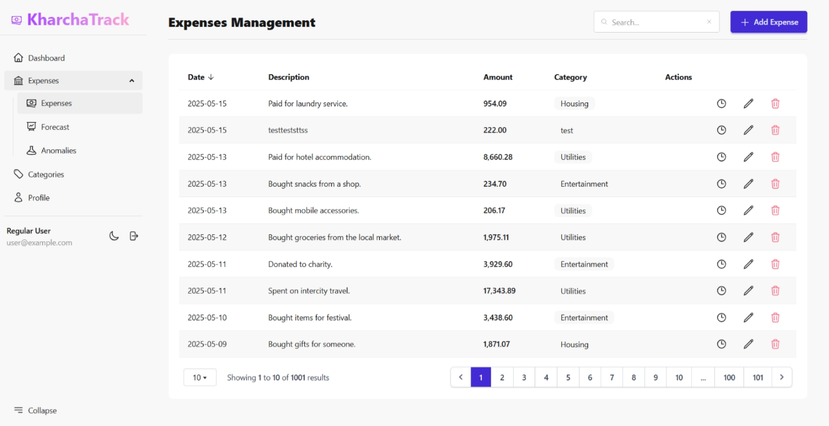

Expenses Page

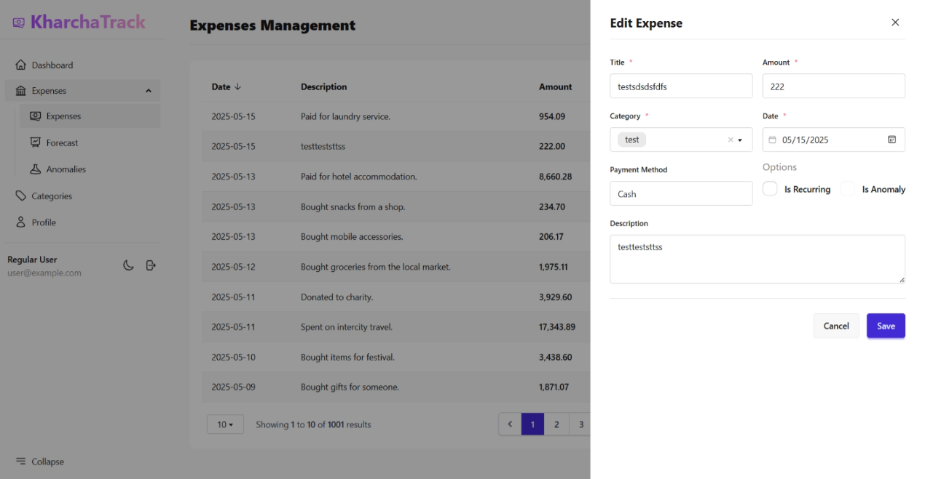

Expense CRUD Panel

Expense Forecast Page

Expense Anomaly Page

Categories CRUD Page

User Profile Page

Admin Dashboard

Admin’s User Management Page

Admin’s Roles Management Page

Admin’s Permission Management Page